Shabbos Stories for
Parshas noach 5782
Volume 13A, Issue 8 - 3 Cheshvan/October 9, 2021
Printed L’illuy nishmas Nechama bas R’ Noach, a”h

For a free subscription, please forward your request to keren18@juno.com
Past stories can be found on the website ShabbosStories.com

Apartment for Sale

Moshe Berger wanted to sell his apartment. One of his neighbors, Yosef Frimmer, heard about it and mentioned to Moshe that Dov Ziskind wanted to buy one. Moshe acted upon Yosef’s suggestion and began a business transaction with Mr. Ziskind.
In the end, Mr. Ziskind bought the apartment. Yosef was not at all involved in any of these dealings. A few days after the deal wascompleted, Moshe called Yosef to thank him for making the suggestion, to which Yosef replied, “You owe me a $500 commission for sending you the customer who bought your apartment.” Moshe was astonished. How could Yosef ask for a commission? he wondered. He’s not a real estate broker and he made no effort whatsoever to see that the sale would be completed. He surely doesn’t deserve a commission, and it takes nerve on his part to even ask!
Yosef, though, was persistent in his stance that the money was coming to him. The two of them decided to go and ask a rav. They were told that even a nonprofessional who only makes a suggestion, or offers information which eventually leads to a sale, is entitled to a commission. Moshe had been sure he was right, and had condemned Yosef for asking, but justice was really on Yosef’s side. (ArtScroll’s The Other Side of the Story, by Yehudis Samet.)

Reprinted from the Parshas Shoftim 5781 email of The Weekly Vort.

The Magic of Shabbat –
A Signal from Heaven
By Rabbi Dovid Goldwasser

The Chatam Sofer tells us that if one is asked to perform a chesed (kindness) or a mitzvah it is a signal from heaven that one has the capacity and the talent to accomplish it.
A number of years ago I was very surprised to receive a call before the summer season to spend Shabbos in a Federation camp. The contact person was very enthusiastic about the concept and importuned me to accept the invitation.
This was a very large camp of over 500 young people from diverse Jewish backgrounds. For many, their only affiliation with Judaism was through birth, and this would be a unique opportunity for me to reach out and kindle that innate spark of Yiddishkeit (Jewishness).

Skeptical and Hesitant
To say the least, I was skeptical, and hesitant to respond in the affirmative. There were many considerations to take into account. What type of Shabbos would this be? What was the ambiance in the camp? Who could give assurance about the kashrut of the food? What kind of davening (prayer services) could I anticipate?
After the third or fourth call encouraging me to participate in this innovative plan for a Federation camp, my resistance was worn down. The administration sincerely wanted to create an authentic Shabbos experience in the camp, and believed that my visit would have a great impact on the lives of all concerned. I agreed to be their Shabbos guest.
The camp driver picked me up early Friday morning. On the way he gave me some more information about the culture and the environment of the camp. He elaborated on the camp’s activities and the facilities that were available. Special preparations had been made to accommodate me, in deference to specific requests that I had made.
We began Friday night with an unprecedented gathering for davening. For many this was their first exposure to praying with a minyan. Although attendance was not mandatory, the administration was shocked when every staff member and camper came to the minyan.

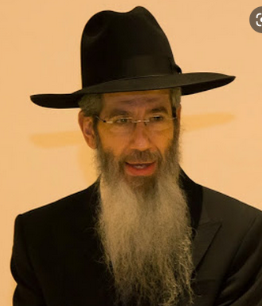
Rabbi Dovid Goldwasser

The setup in the area designated for the service was not adequate, and the services had to be moved outdoors. In fact, most of the participants had to sit on the grass as it was not a practical idea to begin shlepping benches from the dining room which was some distance away.
Those who were familiar with the prayers began to raise their voices in heartfelt unison, singing the familiar niggunim(melodies) and responding to the baal tefillah’s (one who leads the prayer service) intonations. An aura of reverence and admiration pervaded the air as each participant joined in his own way.
It would be difficult to sufficiently describe the special Shabbos spirit that was created that weekend. After the Friday night meal, I conducted a “tisch”, lasting late into the night, exclusively for the staff members, to imbue them with Shabbos “dessert” and to draw them closer.
Before I sat down at the tisch, I went into the kitchen to thank the staff for preparing such a beautiful Shabbos meal and attention to detail.

About to Flip on the
Commercial Dishwasher
When I walked in, some of the kitchen staff were “schmoozing,” and I noticed that one young man looked familiar. I recalled that he had attended a Jewish day school in my neighborhood. Just then, he turned towards the commercial dishwasher at his side, and his hand reached out to flip on the switch. I instinctively shouted, “Wait! You can’t do that! It’s Shabbos!”
He looked up at me in disbelief, and said that he was on kitchen duty, and it was his job to make sure that all the dishes were clean. It was a yeoman task and he had to take care of it immediately, he insisted.
“But you can’t do it,” I said
“Why not?” he angrily demanded
“Because it’s Shabbos,” I gently explained.
He told me he was not religious so it made no difference to him
“It makes no difference,” I told him
“This is my job,” he belligerently asserted, “and I have every intention of doing it.
“You can’t,” I said again.
“Tell me again why not,” he challenged.

Your Washing Will Affect
The Kashrut of the Dishes
“Because if you will wash the dishes it will affect the kashrut of the dishes,” I said.
He looked at me dubiously and said, “So you’re telling me that I’m not allowed to do my job.”
“Not right now,” I answered.
After a few tense moments, he removed his apron, threw it down on top of the table and left. The silence that overwhelmed the kitchen was deafening, as I stood there stunned.
I spent much time ruminating about the conversation that had taken place in the kitchen. Obviously, there was no way I could refrain from speaking up against the destined chilul Shabbos (desecration of the Sabbath). Notwithstanding the Rambam’s instruction that if one sees his fellow man doing a transgression, he should admonish him (hochei’ach tochi’ach es amisecha), I nevertheless regretted the ill-fated interaction.
Although I kept an eye out for the young man, I didn’t see him again the entire Shabbos. On Motzoei Shabbos, I once again spent an inspirational evening with the staff at a seudas Melave Malka of Torah thoughts and inspiration. It was a most memorable occasion.

Committed to Making the
Kitchen Spotlessly Clean
The hour was getting late, and as we were beginning to wind down, I requested some volunteers to help me out in the kitchen. Within one minute I had twenty volunteers. The staff immediately got to work. The dishwasher was turned on, the pots were scrubbed and put away, and the counters were wiped clean. When the last load was finished, every piece of cutlery and every dish was quickly put in its proper place. Within a short time, the kitchen was immaculate.
Just as we were shutting the lights, the young man in charge of the kitchen walked in. He looked around, noted the spotlessly clean kitchen, and wordlessly walked out.
Before I left the next morning, I once again tried to find the young man. I had the deepest desire to placate him so that there were no hard feelings between us. Unfortunately, no one seemed to know his whereabouts.
For a long time I was troubled by the thought that my words may have negatively affected any possible reconnection with Yiddishkeit on his part. I really wanted to have the opportunity to explain what had happened a little more clearly and to ask for his forgiveness. I tried to find him, but he seemed to have disappeared into thin air.

Every Once in a While the
Incident was Recalled
Time passed and, every once in a while, I would recall the incident and wonder if there was any possibility, chas v’shalom, that I might have been instrumental in pushing him further away from Judaism.
Years later I was invited to address a large gathering in Passaic on behalf of Bonei Olam. When I entered the building, some people were milling around in the front. Suddenly a man approached me and said, “Rabbi Goldwasser, I am sure you don’t recognize me. I was the individual at the Federation camp who was about to turn on the dishwasher on Friday night in the kitchen. I want you to know how strongly your gentle words affected me. No one had ever stopped me from pursuing my weekday activities on Shabbos until you came along. There was something in your tone, your words, your sincerity, your care and concern that made a tremendous impact. You stood up for what is right. Little by little, I began my journey back to Torah observance. It is thanks to you that I am here today with my eishes chayil (wife of valor). She is a true Bais Yaakov girl.”
We read in Koheles that “for everything there is a time … a time to be silent and a time to speak” (3:7). The Yismach Yisroel notes that this certainly does not refer to engaging in forbidden speech or idle chatter. One is commanded to always refrain from such speech.
Rather, Shlomo HaMelech is telling us that even when it is necessary to verbalize or express certain thoughts — such as mussar (rebuke) that may be harsh – there is a time to be silent. Sometimes it is preferable that an individual opt not to speak his mind, for it may not be an opportune moment.

Reprinted from the Parshat Shoftim 5781 website of Hidabroot.com

Chassidic Story #1235
Pierre-Louis and
The Baal Shem Tov
From the desk of Yerachmiel Tilles
editor@ascentofsafed.com

One day, the Baal Shem Tov, founder of the Chasidic movement, summoned Rabbi Nissan. He gave his faithful chasid a closed envelope and asked him to travel to the castle of the local landowner, Count Radzvill. Rabbi Nissan was to open the envelope in two-day’s time.
The purpose of this trip was to try to arouse the Count's best friend, Pierre-Louis, to return to Judaism. Rabbi Nissan was perplexed for, as far as everyone knew, Pierre Louis was not Jewish. Yet, he followed his Rebbe's instructions without question.

Liked by Both Jew and Gentile Alike
Count Radzvill was kind and just to all those living on his lands, Jew and gentile alike. On the particular day that Rabbi Nissan arrived at the castle, Count Radzvill and Pierre Louis had just returned from a two-month holiday in Europe. Crowds of people were gathered to welcome them back.
After the two men entered the castle and the crowd had dispersed, Rabbi Nissan meandered around the grounds for the rest of the day wondering how he could arrange to speak to Pierre Louis. When night came, Rabbi Nissan traveled into town and slept in the local synagogue.
Early the next morning, Rabbi Nissan returned to the castle hoping to be inspired as to how he could obtain an audience with Pierre Louis. But as he approached the castle, Rabbi Nissan immediately noticed that something was wrong. A large crowd was gathered there, but many of them were crying.

The Count’s Pistol Had Discharged
Rabbi Nissan inquired and found out what had transpired. The Count and Pierre Louis had gone hunting late the night before. When they returned from their successful trip, a tragic accident occurred. The Count tripped on one of the castle steps, his pistol discharged and he suffered a large bleeding wound in his chest.
Despite the attention of the best doctors, all efforts to stop the bleeding had not helped. The Count was dying.
That’s when Rabbi Nissan remembered the envelope the Rebbe had given him. He opened it, took out the letter and began reading. It was a prescription with exact directions how to prepare a salve to cure...a gunshot wound to the chest!
Rabbi Nissan ran to the castle gate waving the letter and demanded to be let in, but the guards refused. Pierre Louis heard the noise from inside the palace and ran out to the gate, obviously irritated, "Jew! What do you want here?" he shouted. "Don't tell me you are a doctor? Leave here immediately!
“Wait!” he shouted even louder. “What is that paper you are holding?"
Rabbi Nissan tried to explain, but the Frenchman snatched the prescription from his hand and began to read. "This is your cure?!" He screamed. "This is nonsense!"

“Let the Jew Try”
He was about to tear it into pieces when one of the doctors emerged from the castle, noticed the commotion and approached. He examined the paper, turned to face Pierre Louis with his back to the Jew and whispered. "They've given up in there. Let the Jew try; it can't hurt."
Minutes later Rabbi Nissan was in the castle, preparing the medicine. Then he began the treatment. Some of it he smeared on the wound, and some of it he applied on various parts of the Count's body. Every few minutes he repeated the process, following the instructions exactly.
To everyone's surprise, the Count stopped hemorrhaging almost immediately! After a few applications he even seemed to be breathing more deeply and evenly. After an hour, instead of being dead as everyone had anticipated, color returned to his cheeks and minutes later he regained consciousness!
The doctors and professors were speechless; they had never seen anything even vaguely like it. Pierre Louis, moreover, was moved to the essence of his very being.
After several hours the Count was strong enough to call Rabbi Nissan to his bedside and thank him. He offered to reward him but the chasid refused. "Seeing you returned to health is my reward. Just continue to treat the Jews kindly," he said. "But, he added, “I do have one request: I wish to speak with Pierre Louis privately."

Relays the Baal Shem Tov’s Message
The bewildered Pierre Louis and Rabbi Nissan went into a side room and closed the door. Rabbi Nissan said, "I am a follower of a great Jew called Rabbi Yisrael Baal Shem Tov. He was the one who wrote that prescription and saved the Count. He told me to come here and tell you to return to Judaism."
Pierre was still in shock from the near death of his friend and then his strange supernatural recovery. And now this?
Pierre just looked at the chasid, eyes wide in disbelief. "Return? Judaism?" He mumbled to himself. "I don’t understand."
"The Baal Shem Tov told me to tell you that your real name is Pesach-Tzvi," continued Rabbi Nissan. "Both your parents were Jewish. Your mother wanted to give you a Jewish education but your father was opposed and prevailed. Eventually you lost your Jewish identity. But now it is time for you to return."
"I don't understand," said Pierre, trying to clear his throat, "Are you saying that I am a Jew? Me! A Jew? It's impossible! Absolutely impossible!"
Pierre Louis refused to discuss the subject further and abruptly ended the conversation. All he agreed only to give it further thought.

A Knock on the Door
Almost a year later Rabbi Nissan heard a knock on his door. He opened it and was surprised to see a bearded Jew standing in front of him whom he didn’t recognize. ‘Don’t you recognize me?” the man queried.
Then Rabbi Nissan realized: It was Pierre Louis, now Pesach Tzvi, returning to the G-d of his fathers.
Source: Adapted by Yerachmiel Tilles from the rendition of Rabbi Tuvia Boltonon his website, OhrTmimim.org, as posted on LChaimWeekly #822
>>>>>>>>>>>>>>>>>>>>>>>>>>>>>>>>>>>>>>>>>>>>>>>>>>>>>>>>>
Connection : The Weekly Reading of Shoftim contains a strong exhortation (Deut. 18:13-15) to not be led astray by non-Jewish practices, and for spiritual; guidance to listen only to the Jewish prophet of the time.
Biographical note : Rabbi Yisrael ben Eliezer [of blessed memory: 18 Elul 5458 - 6 Sivan 5520 (Aug. 1698 - May 1760 C.E.)], the Baal Shem Tov [Master of the Good Name often referred to as the Besht for short], a unique and seminal figure in Jewish history, revealed his identity as an exceptionally holy person, on his 36th birthday, 18 Elul 5494 (1734 C.E.), and made the until-then underground Chasidic movement public. He wrote no books, although many works claim to contain his teachings. One available in English is the excellent annotated translation of Tzava'at Harivash, published by Kehos.

Reprinted from the Parshat Shoftim 5781 email of KabbalahOnline.org, a project of Asccent of Safed.

What Does the Last Name Landau Mean?
By Menachem Posner

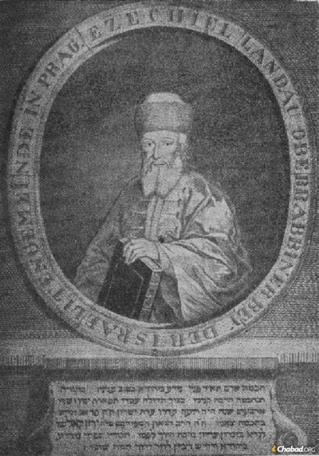
Rabbi Yechezkel Landau was the chief rabbi of Prague.

The Jewish family name Landau can be traced to the town of Landau in der Pfalz, in the heart of Germany’s wine country, not far from the French border. The city had a Jewish community that lasted from the 12th century until the Holocaust.
Fun fact: In addition to many prominent (and not so prominent) Jews, the city also lent its name to a certain horse-drawn carriage with a retractable fabric roof, which is still used by the British royal family.
Many Landaus trace their lineage to Rabbi Yehuda Landau, the city’s rabbi. Some of his descendants traveled south, founding the Italian branch of the family. In time, they headed east, to Moravia and Poland.
Since the “au” sound is not easily pronounced by many Eastern-European Jews, who would more easily recognize לנדוי as “lan-doy,” the name has often been modified to Landa (לנדא) or Lando (לנדו).
Perhaps the most famous member of the Landau family is Rabbi Yechezkel HaLevi (Segal) Landau, Chief Rabbi of Prague, known by the name of his major Halachic work, the Node BiYehudah.
In modern times, the name has been closely associated with three successive generations of Landas who have served as Chief Rabbis to the city of Bnei Brak in Israel. The first, Rabbi Yaakov Landa (1893-1986), was previously the in-house rabbi for the household of the fifth Rebbe, Rabbi Sholom Dovber Schneersohn. Under the leadership of his son, Rabbi Moshe Yehuda Leib Landa (1935-2019), the Landa name became synonymous with high-level kosher certification, as he (like his father) provided his stamp of approval at no cost to any company willing to comply with his exacting requirements. Their legacy is continued by Rabbi Isaac Landa.
Today, the Landau family tree has fruitful branches (some Levites, and others who are not) in Israel, the US, Europe, and virtually everywhere else Jews live.

Reprinted from the Parshat Shoftim email of Chabad.Org Magazine.

The Non-Religious Soldier And His Torah Commitment

Reb Moshe (fictional name) was traveling home to Bnei Brak, with traffic moving as slow as it always did on Erev Shabbos. With the Fridays getting shorter, it was a test of his patience to be able to navigate traffic in order to arrive home in a timely fashion.
Friday was the day that he lectured in Rishon L’tzion. It was a kiruv, outreach, programme which took precedence over his Erev Shabbos errands, because inspiring even one neshamah, soul, was of immeasurable value.
He was lost in thought when he chanced upon a soldier standing on the side of the road seeking a hitch. Reb Moshe figured that the young soldier was also in a rush to reach his destination before Shabbos. He pulled over and offered him a ride. He told the fellow that he was on his way to Bnei Brak. He would be happy to have him join him as far as he was traveling.

The Soldier Happily Jumps into Reb Moshe’s Car
The soldier jumped into the car, happy that after thirty minutes of waiting, someone finally stopped for him. “There should be more Jews like you,” the young soldier, whose name was Gabi, said.
Reb Moshe countered that people were in a rush to make it home in time for Shabbos. “How far do you have to travel?” R’ Moshe asked Gabi. He gave him the name of a kibbutz that was quite distant from Bnei Brak. R’ Moshe asked the obvious question. “How do you expect to reach your destination in time for Shabbos?”
“I do not expect to make it, because I do not observe Shabbos.”
“Why not join me and my family for Shabbos and continue on home after Shabbos?”
“My family is expecting me for the weekend,” Gabi replied.
“This is what a telephone is for,” R’ Moshe said. “Why not call them and say that you are late and have decided to spend Shabbos in Bnei Brak?”
Veritably, Gabi was exhausted and did not mind spending Shabbos with this kind, observant Jew. Shabbos was not really his “thing,” but if it meant sleep and a decent meal, why not?

Agrees to Accept the Shabbos Invitation
“Fine, I accept your offer of hospitality.”
Gabi actually enjoyed the Shabbos experience with R’ Moshe’s family. The negative impression that the teachers in the secular school that he had attended as a youth had drummed into his mind was not consistent with this wonderful family and the warm, welcoming Shabbos experience that he enjoyed.
After Havdalah, Gabi turned to R’ Moshe and said, “I would like to take something along with me as a memento of the wonderful Shabbos I spent with your family.”
“What would you like?” R’ Moshe asked.
“Well, I do not want to become dati, observant, but I would like to accept upon myself to do something as a token of this Shabbos.”
“Perhaps you would like to observe Shabbos.”
“No, no, I am not ready for that” was Gabi’s immediate reply.
“What about kashrus?”
“Also no. It is much too difficult to undertake. Just suggest something simple and easy, and I will do it.”
Reb Moshe murmured, “No Shabbos, no kashrus, and you say that your Tefillin have not been touched since your bar mitzvah. I do not know what to suggest. We will open up the Kitzur Shulchan Aruch, which is a collection of Jewish laws, and see what we can find.”
He opened up the Kitzur, and the first halachah that struck him was the law concerning how one puts on his shoes and ties his laces.

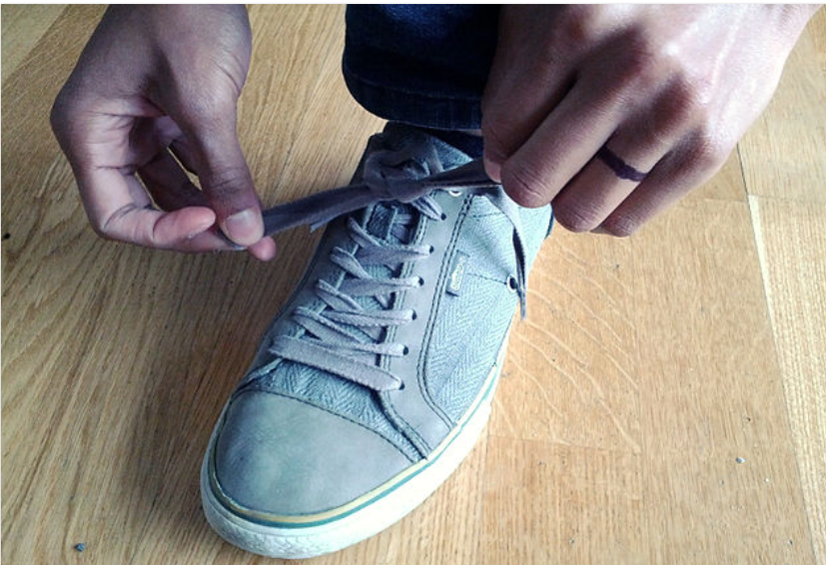

“There is a Torah concerning how one dresses himself?” Gabi asked.
R’ Moshe explained that Torah encompasses every aspect and facet of life. Gabi agreed that following the rules of lacing his shoes would be his mitzvah, the mitzvah that would remain with him as a memento of his Shabbos in Bnei Brak. Gabi bid R’ Moshe and his family goodbye and left for home.
A week later, he was back at his base when he began a series of intense training courses. During this entire time, Gabi never failed to lace his shoes in accordance with halachah. [The right shoe is put on first; the left shoe is tied first.] One night, he was awakened from a deep sleep and instructed by his commanding officer to dress in full gear and board one of two training helicopters that would take the soldiers on a mission. As Gabi was running to the helicopter, he remembered that in his haste he had forgotten to lace his shoes properly. He had given his word never to deviate from the halachah of putting on one’s shoes properly. He told the commander that he must return to his barracks to put on his shoes properly.
The commander thought that Gabi had lost his mind. “Absolutely not!” the commander shouted above the noise of the helicopter rotors that were warming up in anticipation of their passengers.
Gabi insisted on returning. The commander warned him that returning to the barracks meant ignoring a direct order, which was punishable by a week in the stockade.
Gabi replied, “I will do what I must do, and you will do what you must do.” That is exactly how the altercation played itself out. Gabi returned to the barracks, only to be arrested and placed in the stockade.
A few hours later, Gabi was lying on the hard floor of the stockade when the word of the tragic mid-air collision of two helicopters reached him. All seventy-three soldiers on board the helicopters were killed. This was a disaster of epic proportion. Had Gabi not returned to the barracks to lace his shoes in accordance with halachah, he would have been one of the victims.
Commitment, altering his existing lifestyle by accepting upon himself to follow one of the Torah’s imperatives in what many would consider a mundane, non-essential area of endeavour, saved his life. Torah saves.

Reprinted from the Parshas Shoftim 5781 email of Rabbi A.L. Scheinbaum’s Peninim on the Torah.

A Lifesaving Chesed

Rabbi Yoel Gold told a story about an unlikely couple who were clearly meant to be, from an incredible act of kindness. Yisrael and Aviva knew each other well in college, but they were always missing each other when it came to dating. When he was available, she was busy. When she was available, he was busy. When they finally started dating and were going to get engaged, they were both on very different religious levels, and they were afraid to introduce each other to their respective families. They decided they would dip their toes, and introduce Yisrael to Aviva’s grandfather, who was in his nineties and no longer able to speak, besides quietly reading Tehillim in his bed.

When Aviva brought Yisrael into her grandfather’s room, he looked up at Yisrael and said, “Oh, Heshy’s yingele (Yiddish for Heshy’s boy),”
Yisrael said, “How do you know that Heshy is my grandfather?” Aviva’s grandfather did not answer and continued to read his tehillim. Yisrael decided to research this, and what he found was astounding!
Yisrael and Avivas grandfathers were both attending the Satmar Yeshiva before the war. When the Nazis came in to Hungary, they sent the yeshiva boys to the same camp, Mauthausen. During the time leading up to the camp’s liberation, the Nazis grouped many Jews together to exterminate them in huge numbers so they can cover up some of the atrocities that were committed there. They gathered a huge group of boys over a mass grave and began shooting them so they can fall into the pit.
Aviva’s grandfather was shot, and Yisrael’s grandfather wasn’t but he had fallen into the pit. Yisrael’s grandfather stayed in the pit for two days, unmoving. When he knew no one would find them, he crawled out of the pit and started to seek out anyone who was alive so he could pull them out. He pulled out dozens of bodies and helped them with their injuries so they could hide for the next few days. One of the people he carried out was Aviva’s grandfather.
The couple knew this was completely meant to be and decided to get married. Unfortunately, Aviva’s grandfather didn’t make it to the wedding, but Yisrael’s did. The couple went on to have many children, and the first stop with every new baby before going home from the hospital was Yisrael’s grandfather’s house, to show him how honored they are to be continuing his family.

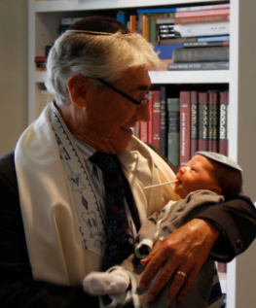

Reprinted from the Parashat Shoftim 5781 email of Jack E. Rahmey based on the Torah teachings of Rabbi Amram Sananes.

